FLUORESCENCE MICROSCOPIC ANALYSIS OF CELL FUNCTION

The Electro-Magnetic Spectrum
The electromagnetic spectrum covers a broad range of energies or wavelengths. For example, an X-ray photon (λ ~ 0.1 ηm) is 10 thousand times more energetic than a photon emitted by an incandescent tungsten wire (λ ~ 1 μm). The Figure below depicts the major subdivisions of the electromagnetic spectrum; note the region where the eye is sensitive (visible) is relatively small. Such diverse radiations as gamma or radio waves differ from visible light only in frequency and hence energy, and it is the energy that level determines the type of interactions a given wavelength will have with biological matter.
Ultraviolet-visible
10⁴
1
10⁻²
10⁻⁴
10⁻⁶
10⁻⁸
10⁻¹⁰
10²
10⁷
10⁹
10¹¹
10¹³
10¹⁵
10¹⁷
10¹⁹
10²¹
Radio
(nmr)
Micro
Vacuum
Ultraviolet
X-ray
Wavelength (cm)
Type of
Spectrophotometry
Infrared
Red
Violet
Blue
Green
Yellow
Orange
Ultraviolet
200
400
600
800
Expanded
UV-visible
region

‘Functional Fluorescence’

Absorbance: Many biological molecules absorb visible light (~ 400-700 nm). Energy is absorbed only when an incident photon has energy equal to the energy difference between the ground and single allowable excited state (wavelength specific). The relation between absorbance and concentration of a molecule is precisely defined by the Beers Law:

Absorbance (A) = [species] * extinction coefficient.

In dilute solution, A is linearly related to [ ] and the slope = the extinction coefficient.

Fluorescence: Absorbing molecules decay from their excited states with varying time constants. If decay occurs in <10⁻¹² s, then only absorbance occurs and the photon energy is lost as heat. If decay is delayed then either fluorescence (10⁻⁸s) or phosphorescence (10³ s) can occur. In general, fluorescent molecules have multiple double-conjugate bonds forming mobile electron clouds that are important for a delayed transition period required for the fluorescent event. Fluorescing molecules release a portion of the absorbed energy as light and the rest as heat. So the energy of emitted light is equal to the difference between the absorbed photon and the energy lost as heat; i.e., fluorescence wavelength is always longer than the wavelength of the absorbed photon. The difference between excitation and emission wavelength is called a STOKES shift. Fluorescence intensity is not linearly related to the concentration of the fluorescing species.

Ab – Absorbance; Fl – Fluorescence; E- energy

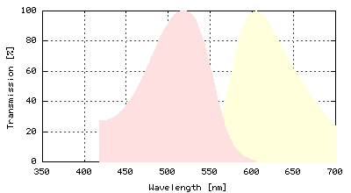
Basic Characteristics of Fluorescent
Molecules- Excitation and Emission Spectra:
Shown to the right is the profile of excitation
and emission wavelengths for the RNA/DNA
binding fluorescent probe ethidium bromide.
The Stokes Shift is the distance in nm from the
peak absorbance to peak emission wavelengths.
These profiles represent a statistical distribution:
all molecules exhibit a similar Stoke Shift, but
each individual molecule exhibits a specific
wavelength of absorption with the majority of
molecules absorbing near the peak wavelength.
Pink- Excitation, Yellow – Emission profiles
Quantum efficiency: How much fluorescence do you get per molecule?
Benezene
Fl
Aniline
Fl
Nitro-Benezene
None
NH₂
NO₂

Molar Extinction:
a. Concentration: inner filter. b. Temperature : Phenol, Analine c. pH : Analine

Effects on Molar Extinction:
P
Phenol Concentration TEMPERATURE

Calcium Green: fluorescence enhancement FURA-2: absorbance (Excitation) shifts
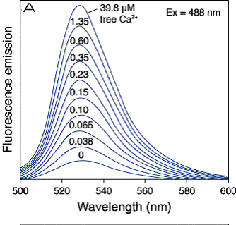
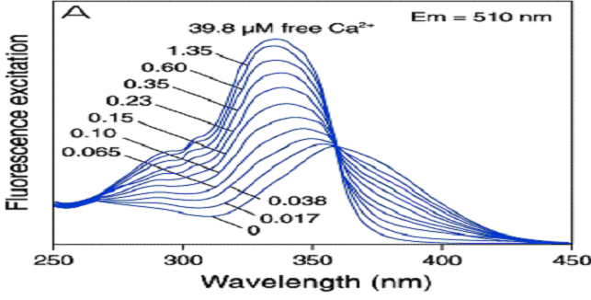

Effects of Ion Concentrations: Basis for Ion Sensitive Fluorophores.
Fluorescence Bleaching: The basis for fluorescence is the absorption of energy (as light), with its subsequent conversion. The reason molecules containing double bonds with π elections are good at absorbing visible light is the fact that the bond energies are equivalent to the energy of the absorbed light. However, the absorption of this energy by elevating the energy state of π electrons make the bond itself susceptible to damage. This is particular true if oxygen radicals are formed during the energy conversion. Damage of the bond leads to loss of its ability to absorb light and therefore decreased the fluorescence in the illumination field. Addition of anti-oxidants, such as in immunochemical preparations retard photobleaching.

FRAP: Fluorescence Recovery After Photobleaching: The property of photobleaching can be used to monitor diffusion of fluorophores within cells. A small spot is illuminated using a high energy power source, then images are rapidly collected to follow the return of fluorescence to the photo-bleached region. Such experiments have been performed to determine mechanisms and rates of diffusion for soluble factors in the cytosol, as well as membrane associated phospolipids and receptors

Forster (Fluorescence) Resonance Energy Transfer: FRET
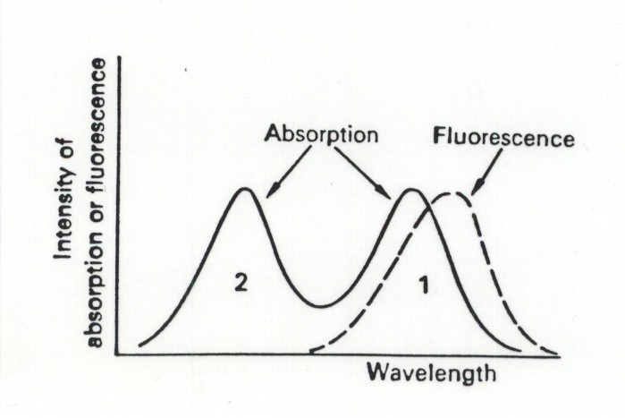
Absorption
Fluorescence
Wavelength
Int ens i ty

Shown is an idealized view of how resonance energy transfer occurs. Two fluorophores are chosen such the light emitted by the blue most probe is at a wavelength that is absorbed by the second probe. The ability (probability) of the second probe to absorb the light emitted from the first probe demonstrates a strict relation to distance between the molecules. Distances must be in the angstom range. Thus, the two fluorophores must be extremely close together. Historically FRET was performed in solution where probe concentrations could be high enough to meet this criterion. However, a new generation of functional protein probes are currently being developed based on this phenomenon. Any protein which goes through a conformational change is a candidate. If the two fluorophores are conjugated onto the protein in such a way that the distance between them changes during the change in protein conformation, then a change in FRET can be used to follow alterations in conformation- in situ.

Selection of an Imaging Modality
• Temporal Resolution How Fast is the Response? Smooth vs Skeletal Muscle

• Spatial Resolution Large Field of View? Individual Cells within a Field? Subcellular Compartments?

• Spectral Resolution 2-4 Wavelengths: Ion Measurements Wide-Band: Multiple Probes
Illumination source : Lamps and Lasers

Standard Illumination sources include high pressure mercury and xenon lamps and lasers which use specific gases to generate intense collimated beams at specific wavelengths. Lasers are infrequently required, except for special circumstances (Laser Scanning Confocal), and are costly ($20-$500,000). On the other hand, lamps and housings for a variety of different sources with different spectral and intensity characteristics are available at reasonable cost ($500-$2000)
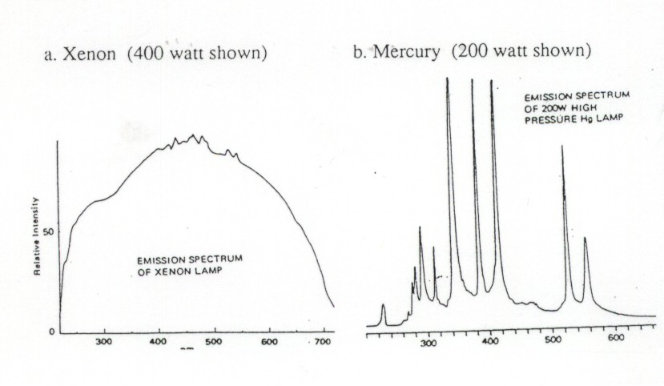

Wavelength Wavelength

Xenon Lamps have rather uniform illumination characteristics over a wide range of wavelengths making them optimal for multiple wavelength excitation. Mercury lamps have distinct lines which are extremely intense (not like a laser though). If you wish to illuminate at one of these lines, a Hg lamp may be optimal. Moreover, even at the lowest output wavelength, a Hg lamp is equally bright as a comparable xenon lamp.
3-Dimensional Imaging: Confocal and Deconvolution Imaging

Laser Scanning Confocal Microscope (LSCM) is now established as a valuable tool for obtaining high resolution images and 3-D reconstructions of a variety of biological specimens.

In LSCM, a laser light beam is focused to a small spot by an objective lens onto a fluorescent specimen then scanned across the specimin. The emitted fluorescent light (at each scanned point) is captured by the objective and focused through a pinhole onto a photodetector (photomultiplier). The confocal aperture (pinhole) placed in front of the photodetector, allows only the fluorescent light from the point of focus to pass to the detector while light from points on the specimen that are not within the focal plane (the so called out-of-focus light) will be largly obstructed by the pinhole. In this way, out-of-focus information (both above and below the focal plane) is greatly reduced. This becomes especially important when dealing with thick specimens. 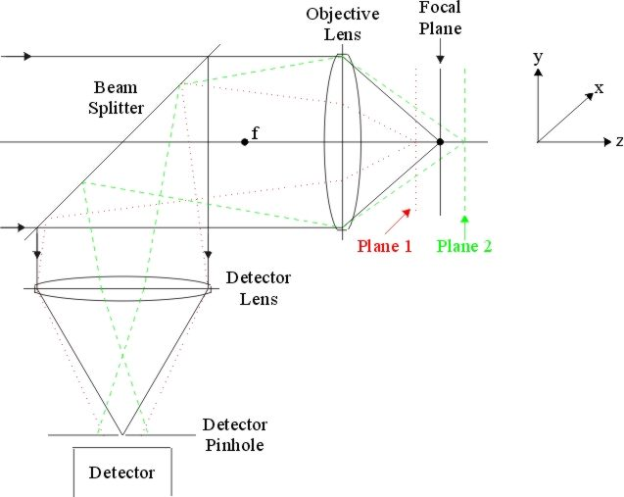

A simple arrangement of a LSCM illustrating the confocal principle.
A 2-D image centered around the focal plane (referred to as an optical section) is generated by performing a raster sweep (scan) of the specimen at that focal plane. As the laser scans across the specimen, the analog light signal, detected by the photomultiplier, is converted into a digital signal, point by point. A 3-D reconstruction of a specimen can be generated by stacking 2-D optical sections collected in series.

Upsides:
Direct viewing from a non-blurry section.
Works great for thick samples.

Downsides:
Laser light is powerful, and can easily bleach the sample- best for fixed preparations.
For 3D imaging scanning in both x,y (2d image) and z-dimensions required- lot’s of bleaching.
Can be rather slow for a full 2D image
2-Photon (2P) Microscopy: Laser Scanning Systems.

2P-microscopy utilizes lasers to scan a spot across a field of view in order to develop an image in the same way a confocal microscope does. However, the laser utilized as the excitation source has a wavelength output that is 2λ longer than the standard excitation split into two perfectly parallel beams. When the beams converge at the point of focus, only over a very small depth of field does the energy from the two independent photons merge – at this point the energy imparted onto the sample (chemical bonds) is 2X the laser wavelength; i.e., the energy at this point will excite fluorophores whose emission is ~½ λ . So to excite fluorescein at 480 nm, a laser emitting at 960 nm would be used. There are two distinct advantages of this approach. 1. the axial resolution (z – axis) is enhanced because out-of-focus blur is limited to the excitation spot – rather than the full cone. This also means that the confocal pinhole is not required to reduce blur, so light throughput increases dramatically allowing viewing of dimmer samples. 2. the higher wavelength (lower energy) light penetrates deeper into a sample than does higher energy light; thus, 480 excitation can be provided much deeper into a (tissue) sample. See slide for demonstration of the difference in illumination field of 1-P and 2-P systems.

3D – Deconvolution Microscopy.

As indicated, in a standard wide-field microscope, light from in-focus and out-of-focus objects is collected, leading to blurring of the image and loss of resolution. However, when a series of images is collected through focus (z-axis) with a small distance between focal planes for each image, each fluorescent object will be in focus in one of the images and out of focus in the other images. Thus analysis of the sample in three dimensions provides information regarding each object in all planes of focus. Information about how the microscope optics blur light can then be used in conjunction with model based algorithms to calculate the origin of the blurred light and remove or deconvolve the blurring by reassigning the light to its point of origin. This approach provides an image with a higher resolution and contrast than the original 3D data, and is comparable (and often superior in resolution) to images produced by confocal microscopy.

Upsides:
Images can be collected rapidly with little photobleaching; images – imaging live cells without photo-damage. Images of dim samples can be acquired – maximized light throughput.

Downsides:
Since image processing is required, it takes time to obtain the final deblurred images.
In thick samples, there is too much information (blurred light) to accurately process the data to obtain high resolution data sets.

Imaging Spectroscopy.

A wide range of fluorescent probes have been developed which are sensitive to changes in ions, metabolites and subcellular structure providing noninvasive or minimally invasive tools to study cell. With these probes in hand, the development of imaging tools which can monitor changes in fluorescence intensity from several probes simultaneously (e.g., Ca²⁺ pH), and to correct probe specific signals for non-specific artifacts is increasingly important. . The basic objective of imaging spectrometry is to monitor the relative intensity of different colors within a narrow and contiguous spectral band at all positions in the microscopes field of view. A wide range of imaging tools have been developed which allow analysis of spectra from light collected from microscopes. Examples will be provided regarding the needs for spectral imaging and the types of applications that it can be applied to.

References:

Confocal Microscopy

Lynch R.M., K.E. Fogarty and F.S. Fay (1991) Analysis of hexokinase association with mitochondria by quantitative confocal microscopy. J. Cell Biol. 112:385-395.

Wide-field Deconvolution Microscopy.
Carrington, W.A., R.M. Lynch, E.D.W. Moore, K.E. Fogarty and F.S. Fay (1995) Super-resolution 3-dimensional images of fluorescence in cells with minimal light exposure. SCIENCE 268: 1483-1487.

Scriven, D.R, R.M Lynch and E.D.W. Moore (2008) Image acquisition for colocalization using optical microscopy. Am. J. Physiol. Cell Physiol. 294(5):C1119-22.

Spectral Imaging.
Ford, B.K., S.M. Murphy, C.E. Volin, R.M. Lynch, and M.R. Decour. (2001) Computed-Tomography based video-rate spectral imaging system for fluorescence microscopy. Biophys. J. 80: 986-993.

Martinez-Zaguilan, R., M. Gurule and R.M. Lynch (1996) Simultaneous Measurement of pH and Ca²⁺ in single insulin secreting cells by microscopic spectral imaging. Am. J. Physiol.: 270 (Cell 40):C1438-1446.

