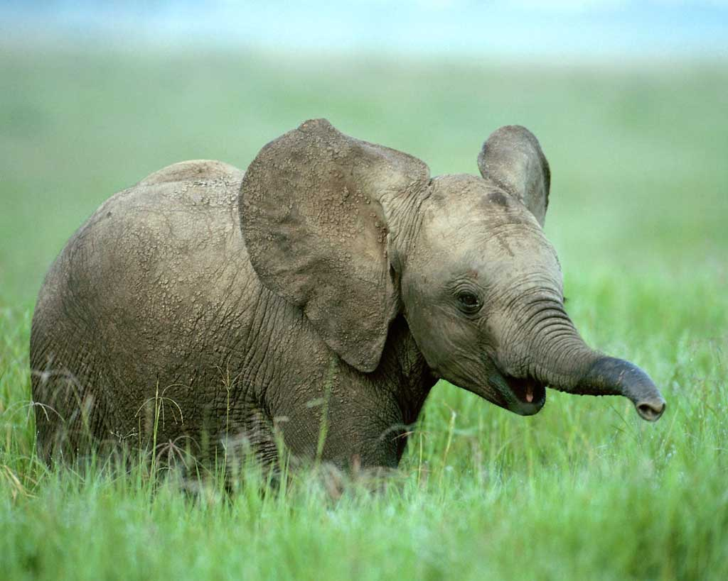

Resources:
- Science news story.
- Word bank.
- Activity 1: Mixed-up meanings.
- Activity 2: Comprehension.
- Activity 3: Find the missing word.
- Activity 4: What kind of statements?
- Activity 5: Topics for group discussions, research and pupil presentations.
- Links to free activities, lesson plans, and background information.
- Daily tip for running science class discussions and groupwork.

News
Atlanta: 30-Oct-2006 17:00 Eastern US Time, EurekAlert.

Elephants in a mirror
Elephants have joined a small group of species that can recognise themselves in a mirror.

This ability is now known to have evolved independently in several branches of animals. It is found only in animals with large brains and complex social lives. Before this latest research only humans, great apes and dolphins were known to possess it.

Awareness of self is found in intelligent animals with well-established social systems, said Joshua Plotnik of the Yerkes National Primate Research Center, Emory University. So too is the ability to distinguish self from others. “The social complexity of the elephant, its well-known altruistic behaviour and, of course, its huge brain, made the elephant a logical candidate species for testing in front of a mirror.”

In the study, researchers showed a jumbo-sized mirror to three female elephants at the Bronx Zoo in New York. The mirror was eight feet high by eight feet wide.

During the research, the elephants were found to test their images in the mirror. They made repetitive body movements. They used the mirror to inspect themselves. They moved their trunks so they could see the insides of their mouths, a part of the body they usually cannot see.

Importantly, the elephants did not react socially to their images. They did not seem to mistake their reflection for that of another animal. Most animals do make this mistake, failing to recognise themselves in a mirror, and sometimes even trying to attack the image.

Elephants have been tested in front of mirrors before, Plotnik explained. “But previous studies used relatively small mirrors, kept out of the elephants' reach. This study is the first to test the animals in front of a huge mirror they could touch, rub against and try to look behind.”

One elephant also passed a standard test known as the mark test. Each elephant was marked with visible paint on its forehead – a place it could not see without a mirror. It also received a sham mark of colourless face paint.

The sham mark was to test if touching the visible mark was a result of seeing its reflection, or of the feel or smell of the paint. This test produced the same results as when great apes and human children are presented with the mark test. Seeing the mark in the mirror, they then touch it on their heads.

As a result of this study, elephants now join a cognitive elite among animals, said Frans de Waal of Yerkes' Living Links Center. It is what would be expected for an animal with the elephant’s complex social life and high level of intelligence.

Elephants are far more distantly related to us than the great apes, he added. But they seem to have evolved similar social and cognitive abilities. “These parallels between humans and elephants suggest a convergent cognitive evolution, possibly related to complex sociality and cooperation.”

Scientists have tested the ability to recognise themselves in a mirror with a variety of animals, other than humans and great apes. They had always failed to find it before except in bottlenose dolphins.

“After the recent discovery that dolphins are capable of recognising themselves in the mirror, elephants seemed the next logical species for testing,” said Diana Reiss of the Wildlife Conservation Society.

“Humans, great apes, dolphins and elephants, well known for their superior intelligence and complex social systems, are thought to possess the highest forms of empathy and altruism in the animal kingdom.”

Further research on elephant thinking and behaviour will be conducted by Yerkes' Living Links Center. This will be aimed specifically at social complexity – including cooperation and conflict resolution – in Asian elephants.

The research was carried out by scientists at the Yerkes National Primate Research Center, Emory University, and the Wildlife Conservation Society in New York. It is published in the current issue of Proceedings of the National Academy of Sciences of the United States of America. It is available in the early online edition. This study is part of a range of cognitive and behavioural evolution topics at Yerkes' Living Links Center.

650 words
Flesch reading ease: 52.3
Flesch-Kincaid Grade level: 10

Word bank
Pupils will not know some of the words used in the text. Meanings are given below, followed by a table mixed randomly – to provide an exercise in matching words and meanings.

By tackling this and the exercises that follow – which are known as directed activities related to texts (DARTs) – pupils can engage with a piece of writing, and learn a great deal from it, even when many of its ideas and words are unfamiliar to them.

 | Word | Meaning
1 | species | group of individuals that are alike and can breed together to produce fertile offspring
2 | recognise | know and remember
3 | complexity | having many connecting parts that are hard to separate
4 | great apes | gorillas, chimpanzees and orang-utans
5 | evolved | happened by evolution
6 | independently | with no connection to each other
7 | cognitive | of activities of the mind, such as thinking and reasoning
8 | behavioural | of the actions of a living thing
9 | evolution | the way living things change over time, through small changes from one generation to the next that help an individual to survive and produce more healthy offspring than others of the same species
10 | awareness | knowledge gained through the senses
11 | established | set up and lasting a long time
12 | distinguish | tell apart
13 | altruistic | thinking and caring for others (opposite of selfish)
14 | logical | reasonable
15 | candidate | one that might do the job
16 | repetitive | done again and again
17 | social | living with others
18 | socially | in the way they would with other individuals
19 | image | likeness formed by a mirror or a lens
20 | reflection | image in a mirror
21 | relatively | compared to the average
22 | standard | used often and widely
23 | visible | able to be seen
24 | sham | fake
25 | elite | a small group with more ability, talent, power, etc.
26 | complex | having many connecting parts that are hard to separate
27 | distantly | far away
28 | related | connected like members of the same family
29 | similar | nearly the same as
30 | convergent | coming together from different directions
31 | sociality | behaviours when living with others
32 | cooperation | working helpfully with others
33 | variety | set of different things; assortment
34 | empathy | the ability to understand and share someone else’s feelings
35 | cognition | thinking or reasoning
36 | conflict | fight, struggle, disagreement
37 | resolution | the solving of a problem
38 | offspring | the young of an animal
39 | fertile | able to produce offspring
40 | breed | produce young creatures
41 | generation | a group of individuals living at the same time
42 | individual | a particular being or thing

Activity 1 Mixed-up meanings

Pupils should try to fill the blanks in the final column with the word that matches the meaning. The words needed are listed, randomly mixed, in the first column.

This exercise should not be tackled in isolation, but by a reader with access to the story itself: The contexts in which words are used provide powerful clues to their meanings.

 | Word | Meaning | Word should be
1 | repetitive | group of individuals that are alike and can breed together to produce fertile offspring
2 | social | know and remember
3 | elite | having many connecting parts that are hard to separate
4 | standard | gorillas, chimpanzees and orang-utans
5 | sociality | happened by evolution
6 | fertile | with no connection to each other
7 | recognise | of activities of the mind, such as thinking and reasoning
8 | established | of the actions of a living thing
9 | distinguish | the way living things change over time, through small changes from one generation to the next that help an individual to survive and produce more healthy offspring than others of the same species
10 | socially | knowledge gained through the senses
11 | reflection | set up and lasting a long time
12 | candidate | tell apart
13 | related | thinking and caring for others (opposite of selfish)
14 | offspring | reasonable
15 | species | one that might do the job
16 | cognitive | done again and again
17 | awareness | living with others
18 | logical | in the way they would with other individuals
19 | image | likeness formed by a mirror or a lens
20 | breed | image in a mirror
21 | relatively | compared to the average
22 | sham | used often and widely
23 | resolution | able to be seen
24 | generation | fake
25 | evolution | a small group with more ability, talent, power, etc.
26 | visible | having many connecting parts that are hard to separate
27 | variety | far away
28 | conflict | connected like members of the same family
29 | complexity | nearly the same as
30 | independently | coming together from different directions
31 | altruistic | behaviours when living with others
32 | behavioural | working helpfully with others
33 | cognition | set of different things; assortment
34 | distantly | the ability to understand and share someone else’s feelings
35 | convergent | thinking or reasoning
36 | great apes | fight, struggle, disagreement
37 | similar | the solving of a problem
38 | evolved | the young of an animal
39 | empathy | able to produce offspring
40 | cooperation | produce young creatures
41 | complex | a group of individuals living at the same time
42 | individual | a particular being or thing

Activity 2 Comprehension

- Name three types of animal that can recognise themselves in a mirror.

- Plotnik gives three reasons for choosing elephants for this piece of research. State two of them.

- How many elephants took part in this research? (Scientists would say: ‘What was the size of the sample?’)

- State two things the elephants did in front of the mirror that made the scientists say the elephants knew they were looking at themselves.

- Name one thing the elephants did not do that also provides evidence that they knew they were looking at themselves.

- Scientists have tested elephants in front of mirrors before, without finding that they recognised themselves. What is a possible explanation of this?

- Why do you think an elephant might realise it is looking at an image of itself, only if a big mirror is used that it can ‘touch, rub against and try to look behind’?

- Briefly, in your own words, what is the mark test?

- What is the point of the second mark made with paint the elephant cannot see?

- What do you think ‘cognitive elite’ means?

- Humans, elephants and dolphins are not closely related species. But they all recognise themselves in a mirror. What is the scientists’ explanation for this?

- Knowing the difference between yourself and others is a first step in realising that others have the same kind of feelings as you do. What word do the scientists use for the ability to recognise these feelings in others?

- When individuals have that ability they often try to treat others as they would like to be treated themselves. What word do the scientist use for this?

- What does ‘evolved independently’ mean?

- The research was carried out on three female elephants. If you were the scientists what further research would you like to do?

- What would be the aims of that research?

- What hypothesis would it be testing?

Activity 3 Find the missing word

Pupils should try to fill in the blanks using clues from the rest of the sentence. When in doubt, the length of each blank indicates the length of the missing word. A complete list of words that belong in the blanks is provided at the end of the passage.

Elephants in a mirror
Elephants have joined a small group __ species that can recognise themselves in a mirror.

This ability is now _____ to have evolved independently in several branches of _______. It is found only in animals with large ______ and complex social lives. Before this latest research only humans, great apes and ________ were known to possess it.

Awareness of self is found in ___________ animals with well-established social systems, said Joshua Plotnik of Yerkes National Primate Research Center, Emory University. So too is the ability to ___________ self from others. "The social complexity of the elephant, ___ well-known altruistic behaviour and, of course, its huge brain, ____ the elephant a logical candidate species for testing in _____ of a mirror."

In the study, researchers showed a ___________ mirror to three female elephants at the Bronx Zoo __ New York. The mirror was eight feet high by _____ feet wide.

During the research, the elephants were found __ test their images in the mirror. They made repetitive ____ movements. They used the mirror to inspect themselves. They _____ their trunks so they could see the insides of _____ mouths, a part of the body they usually cannot ___.

Importantly, the elephants did not react socially to _____ images. They did not seem to mistake their reflection ___ that of another animal. Most animals do make this _______, failing to recognise themselves in a mirror, and sometimes even trying to attack the image.

Elephants have been tested __ front of mirrors before, Plotnik explained. "But previous studies ____ relatively small mirrors, kept out of the elephants' reach. ____ study is the first to test the animals in _____ of a huge mirror they could touch, rub against ___ try to look behind."

One elephant also passed a ________ test known as the mark test. Each elephant was ______ with visible paint on its forehead - a place __ could not see without a mirror. It also received _ sham mark of colourless face paint.

The sham mark was __ test if touching the visible mark was a result of ______ its reflection, or the feel or smell of ___ paint. This test produced the same results as when _____ apes and human children are presented with the mark ____. Seeing the mark in the mirror, they then _____ it on their heads.

As a result of this study, _________ now join a cognitive elite among animals, said Frans __ Waal of Yerkes' Living Links Center. It is what _____ be expected for an animal with the elephant's complex ______ life and high level of intelligence.

Elephants are far ____ distantly related to us than the great apes, he _____. But they seem to have evolved similar social ___ cognitive abilities. "These parallels between humans and elephants suggest _ convergent cognitive evolution, possibly related to complex sociality and ___________."

Scientists have tested the ability to recognise themselves __ a mirror with a variety of animals, other than ______ and great apes. They had always failed to find it ______ except in bottlenose dolphins.

"After the recent discovery that ________ are capable of recognising themselves in the mirror, elephants ______ the next logical species for testing," said Diana Reiss __ the Wildlife Conservation Society.

"Humans, great apes, dolphins and elephants, ____ known for their superior intelligence and complex social systems, ___ thought to possess the highest forms of empathy and ________ in the animal kingdom."

Further research on elephant thinking ___ behaviour will be conducted by Yerkes' Living Links Center. ____ will be aimed specifically at social complexity - including ___________ and conflict resolution – in Asian elephants.

The research was carried out by __________ at the Yerkes National Primate Research Center, Emory University, ___ the Wildlife Conservation Society in New York. It is published __ the current issue of Proceedings of the National Academy __ Sciences of the United States of America. It is _________ in the early online edition. This study is part __ a range of cognitive and behavioural evolution topics at _______ Living Links Center.

These are all the words that belong in the blanks:
a, a, added, altruism, and, and, and, and, animals, are, available, before, body, brains, cooperation, cooperation, de, distinguish, dolphins, dolphins, eight, elephants, for, front, front, great, humans, in, in, in, in, intelligent, it, its, jumbo-sized, known, made, marked, mistake, more, moved, of, of, of, of, scientists, see, seeing, seemed, social, standard, test, the, the, their, their, This, This, to, to, touch, used, well, would, Yerkes’

Answer Key:

Elephants in a mirror
Elephants have joined a small group of species that can recognise themselves in a mirror.

This ability is now known to have evolved independently in several branches of animals. It is found only in animals with large brains and complex social lives. Before this latest research only humans, great apes and dolphins were known to possess it.

Awareness of self is found in intelligent animals with well-established social systems, said Joshua Plotnik of the Yerkes National Primate Research Center, Emory University. So too is the ability to distinguish self from others. "The social complexity of the elephant, its well-known altruistic behaviour and, of course, its huge brain, made the elephant a logical candidate species for testing in front of a mirror."

In the study, researchers showed a jumbo-sized mirror to three female elephants at the Bronx Zoo in New York. The mirror was eight feet high by eight feet wide.

During the research, the elephants were found to test their images in the mirror. They made repetitive body movements. They used the mirror to inspect themselves. They moved their trunks so they could see the insides of their mouths, a part of the body they usually cannot see.

Importantly, the elephants did not react socially to their images. They did not seem to mistake their reflection for that of another animal. Most animals do make this mistake, failing to recognise themselves in a mirror, and sometimes even trying to attack the image.

Elephants have been tested in front of mirrors before, Plotnik explained. "But previous studies used relatively small mirrors, kept out of the elephants' reach. This study is the first to test the animals in front of a huge mirror they could touch, rub against and try to look behind."

One elephant also passed a standard test known as the mark test. Each elephant was marked with visible paint on its forehead - a place it could not see without a mirror. It also received a sham mark of colourless face paint.

The sham mark was to test if touching the visible mark was a result of seeing its reflection, or the feel or smell of the paint. This test produced the same results as when great apes and human children are presented with the mark test. Seeing the mark in the mirror, they then touch it on their heads.

As a result of this study, elephants now join a cognitive elite among animals, said Frans de Waal of Yerkes' Living Links Center. It is what would be expected for an animal with the elephant's complex social life and high level of intelligence.

Elephants are far more distantly related to us than the great apes, he added. But they seem to have evolved similar social and cognitive abilities. "These parallels between humans and elephants suggest a convergent cognitive evolution, possibly related to complex sociality and cooperation."

Scientists have tested the ability to recognise themselves in a mirror with a variety of animals, other than humans and great apes. They had always failed to find it before except in bottlenose dolphins.

"After the recent discovery that dolphins are capable of recognising themselves in the mirror, elephants seemed the next logical species for testing," said Diana Reiss of the Wildlife Conservation Society.

"Humans, great apes, dolphins and elephants, well known for their superior intelligence and complex social systems, are thought to possess the highest forms of empathy and altruism in the animal kingdom."

Further research on elephant thinking and behaviour will be conducted by Yerkes' Living Links Center. This will be aimed specifically at social complexity - including cooperation and conflict resolution - in Asian elephants.

The research was carried out by scientists at the Yerkes National Primate Research Center, Emory University, and the Wildlife Conservation Society in New York. It is published in the current issue of Proceedings of the National Academy of Sciences of the United States of America. It is available in the early online edition. This study is part of a range of cognitive and behavioural evolution topics at Yerkes' Living Links Center.

Activity 4 What kind of statement?

Students should read the news story on page 1 about the latest scientific research, and highlight phrases or sentences according to the following key (or any other ways of highlighting the different types of statements that can be done with the resources in your pupils’ pockets or in your science classroom):

Existing knowledge
Aims of the research
Technology and methods
New findings
Hypothesis
Prediction
Evidence
Issues and applications

Normally no more than one phrase or sentence should be highlighted in each paragraph, unless the reader decides that a particular paragraph contains several really important ideas.

Usually the decision will not be too difficult. But choosing between, say, hypotheses, new findings and predictions can sometimes be tricky. There isn’t always an obviously right or wrong answer, even to the scientists themselves.

Pupils should be encouraged not to agonise too long over their choice of statement type, but to be prepared to give reasons for their decisions.

Note: A hypothesis is a “tentative explanation that leads to predictions which can be tested by experiment or observation”.

Answer Key: (This is an illustrative set of choices. There are many others.)

Elephants in a mirror
Elephants have joined a small group of species that can recognise themselves in a mirror.

This ability is now known to have evolved independently in several branches of animals. It is found only in animals with large brains and complex social lives. Before this latest research only humans, great apes and dolphins were known to possess it.

Awareness of self is found in intelligent animals with well-established social systems, said Joshua Plotnik of the Yerkes National Primate Research Center, Emory University. So too is the ability to distinguish self from others. “The social complexity of the elephant, its well-known altruistic behaviour and, of course, its huge brain, made the elephant a logical candidate species for testing in front of a mirror.”

In the study, researchers showed a jumbo-sized mirror to three female elephants at the Bronx Zoo in New York. The mirror was eight feet high by eight feet wide.

During the research, the elephants were found to test their images in the mirror. They made repetitive body movements. They used the mirror to inspect themselves. They moved their trunks so they could see the insides of their mouths, a part of the body they usually cannot see.

Importantly, the elephants did not react socially to their images. They did not seem to mistake their reflection for that of another animal. Most animals do make this mistake, failing to recognise themselves in a mirror, and sometimes even trying to attack the image.

Elephants have been tested in front of mirrors before, Plotnik explained. “But previous studies used relatively small mirrors, kept out of the elephants' reach. This study is the first to test the animals in front of a huge mirror they could touch, rub against and try to look behind.”

One elephant also passed a standard test known as the mark test. Each elephant was marked with visible paint on its forehead – a place it could not see without a mirror. It also received a sham mark of colourless face paint.

The sham mark was to test if touching the visible mark was a result of seeing its reflection, or the feel or smell of the paint. This test produced the same results as when great apes and human children are presented with the mark test. Seeing the mark in the mirror, they then touch it on their heads.

As a result of this study, elephants now join a cognitive elite among animals, said Frans de Waal of Yerkes' Living Links Center. It is what would be expected for an animal with the elephant’s complex social life and high level of intelligence.

Elephants are far more distantly related to us than the great apes, he added. But they seem to have evolved similar social and cognitive abilities. “These parallels between humans and elephants suggest a convergent cognitive evolution, possibly related to complex sociality and cooperation.”

Scientists have tested the ability to recognise themselves in a mirror with a variety of animals, other than humans and great apes. They had always failed to find it before except in bottlenose dolphins.

“After the recent discovery that dolphins are capable of recognising themselves in the mirror, elephants seemed the next logical species for testing,” said Diana Reiss of the Wildlife Conservation Society.

“Humans, great apes, dolphins and elephants, well known for their superior intelligence and complex social systems, are thought to possess the highest forms of empathy and altruism in the animal kingdom.”

Further research on elephant thinking and behaviour will be conducted by Yerkes' Living Links Center. This will be aimed specifically at social complexity – including cooperation and conflict resolution – in Asian elephants.

The research was carried out by scientists at the Yerkes National Primate Research Center, Emory University, and the Wildlife Conservation Society in New York. It is published in the current issue of Proceedings of the National Academy of Sciences of the United States of America. It is available in the early online edition. This study is part of a range of cognitive and behavioural evolution topics at Yerkes' Living Links Center.

Activity 5 Topics for group discussions, research and pupil presentations

Three abilities are often said to distinguish humans from other animals:

- Language
- Self awareness
- The ability to make moral decisions

But science, such as the research on elephants in this news story, is showing that these abilities are not unique to humans:
Language
Animals communicate with each other in many ways. Some can even learn human language. Koko is a female gorilla who has been taught to use 1000 words in American sign language. Washoe the chimpanzee was brought up as a human child and learned many words in sign language.

Self awareness
The mirror test demonstrates self-awareness. Humans, dolphins, chimpanzees, orang-utans – and now elephants – pass the mirror test. They manoeuvre in front of the mirror to closely examine parts of their bodies they normally can’t see.

Morality
Humans are not the only animals that make moral decisions. In Shadows of Forgotten Ancestors, Carl Sagan and Ann Druyan describe an experiment with monkeys in a laboratory:

The monkeys were fed if they pulled a chain to electrically shock another monkey, not a relative, whose agony was obvious through a one-way mirror. If the monkey did not pull the chain it was not fed. The monkeys often refused to pull the chain. In one experiment 87% preferred to go hungry. One monkey went without food for nearly two weeks rather than hurt its fellows.

(The above is adapted from the Bioethics Education Project: http://www.beep.ac.uk/content/index.php)
Question for discussion: If animals such as elephants, apes, monkeys, whales and dolphins possess language, self-awareness and morality, should they not be treated as we try to treat other humans – as persons rather than resources to be exploited or objects to be experimented upon?

Links to free activities, lesson plans, background information
- http://www.sciam.com/article.cfm?articleID=0002433B-A643-1C5E-B882809EC588ED9F http://www.jhu.edu/~newslett/05-3-01/Science/2.html Background articles on Dolphin self-awareness and the mirror test. From Scientific American and Science.

- http://www.awf.org/wildlives/screensaver.php African elephant screensaver. Also gorilla and antelope. From African Wildlife Foundation.

- http://school.discovery.com/lessonplans/programs/greatapes Imaginative lesson plan on the nature of intelligence in great apes. From Discovery School.

- http://school.discovery.com/lessonplans/programs/ultimateguide-elephants/q.html Video and lesson plan on how elephants use their body parts to stay upright, stay cool and find a square meal. “You’ll also see evidence that this intelligent giant may have a sense of humour.”

- http://www.save-the-elephants.org/news.asp?linkID=34&articleID=1526 Studies showing empathy in elephants. (There’s a link to the full article third from the top in the Publications section.)

- http://school.discovery.com/lessonplans/programs/ivorywars/ Ivory Wars Structured research and discussion lesson on using elephants for ivory. From Discovery School.

- http://www.sciencenetlinks.com/lessons.cfm?BenchmarkID=6&DocID=388 Lessons on animal communications. From American Association for the Advancement of Science.

- http://www.awf.org/wildlives/71 Informative background on elephants and their social lives. From African Wildlife Foundation.

Link to more links
http://elephant.elehost.com/index.html Elephant information repository. Includes good and bad news, video and photos, family structure, life-cycle, conservation and stories about elephants.

Daily tips for running science class discussions and groupwork

Three components support good discussions in science and ethics: science content, a decision-making framework, and a familiarity with ethical perspectives. These elements are shown below:

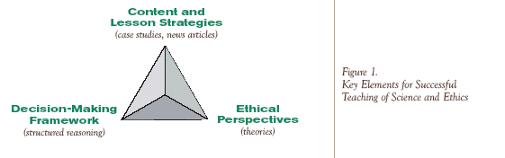

A useful approach to ethics in science is through exploring a case study. This leads naturally to a discussion of the need for the other two elements.

Students can be overwhelmed if they meet ethical perspectives before they have been presented with an ethical dilemma. The science content and strategies provide the ‘hook’ for student engagement.

(Adapted from An Ethics Primer by Northwest Association for Biomedical Research. This is a detailed study of, and practical advice on, learning and teaching ethics in science. Free to teachers through simple online registration. http://www.nwabr.org/education/ethicslessons.html)

