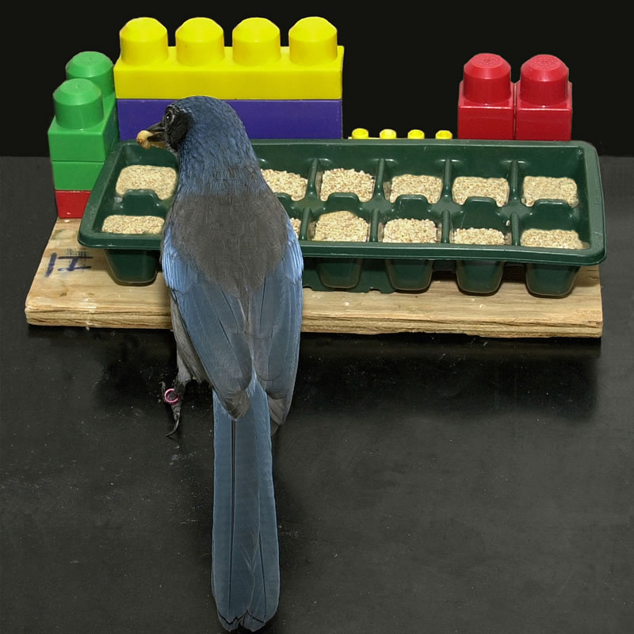

Resources:
Science news story.
Word bank.
Activity 1: Mixed-up meanings.
Activity 2: Comprehension.
Activity 3: Find the missing word.
Activity 4: What kind of statements?
Activity 5: Topic for group discussion or pupil presentations.
Links to free activities, lesson plans and background information.
Daily tip for running science class discussions and groupwork.

News
University of Cambridge. 21-Feb-2007. Eurekalert

Bird brain
Some birds recognize the idea of the future and plan for it, researchers at the University of Cambridge have discovered. Western scrub jays will store food they believe will be in short supply sometime in the future.

The findings are published today in the journal Nature.

Planning for the future is a complex skill. It has always been thought that only humans had the brainpower needed for it. Other animals were believed to be unable to think about anything other than the present and their immediate needs.

Sometimes animals do seem to recognize future needs. But they are usually showing behavior that is driven by instinct, such as building a nest. Or the behavior arises from immediate needs like hunger. Food hoarding is a good example of this.

Professor Nicky Clayton and her team at the Department of Experimental Psychology carried out experiments on the western scrub jay. Their aim was to see if some animals plan for future food needs, or always act on instinct.

The experiment worked like this. Every morning, eight scrub jays were allowed into one of two compartments. The first contained breakfast, the second had no food at all. The birds were then allowed to eat for the rest of the day.

After several days, the birds were given pine nuts in the evening. The scrub jays hid food in the ‘no breakfast’ compartment rather than the ‘breakfast’ compartment. This showed they understood their future needs. They were not just dealing with their immediate needs.

In a second experiment, the scrub jays were given either dog food in one compartment or peanuts in another. They were allowed to hoard either of these foods where they liked in the evenings.

The birds were found to hoard peanuts in the dog food compartment and dog food in the peanut compartment.

This again showed an understanding of future needs, as well as a desire for a varied diet. If the jays were storing the food for present hunger, they would not have made a difference between the types of food or where they stored it.

The birds’ behavior shows they are concerned about two aspects of food in the future, says Professor Nicky Clayton – guarding against shortages and getting variety in their diets.

“It suggests they have advanced and complex thought processes, as they have a sophisticated concept of past, present and future, and factor this into their planning.”

Together with her colleague Professor Tom Dickinson, Professor Clayton and her team have published a number of papers that demonstrate the remarkable memories of scrub jays. Some forms of memory and future thinking are believed to be linked in the human brain. The scientists were interested to see if the same might be true of the scrub jay brain.

460 words
Flesch reading ease: 60.6
Flesch-Kincaid Grade level: 8.6

Word bank
Pupils will not know some of the words used in the text. Meanings are given below, followed by an exercise in matching words and meanings.

Teachers may choose to provide some or all of the meanings to help pupils read and understand the story. An approach that leads to better learning is to ask pupils to complete as much of Activity 1 as possible during their first encounter with the text.

By tackling this exercise and those that follow – which are known collectively as directed activities related to texts (DARTs) – pupils can engage with a piece of writing, and learn a great deal from it, even when many of its ideas and words are unfamiliar to them.

 | Word | Meaning
1 | aspect | one part of a problem or situation
2 | behavior | the actions of an animal in response to its environment
3 | compartment | small room or space
4 | complex | having many connecting parts that are hard to separate
5 | concept | a general idea
6 | concerned about | planning for
7 | desire | wanting something a lot
8 | environment | everything in the surroundings that can have an effect
9 | experiment | a practical test
10 | factor | take account of
11 | hoard | store away
12 | hoarding | storing away
13 | immediate | happening now
14 | instinct | built-in behavior that does not have to be learned
15 | recognize | know and remember
16 | remarkable | unusual; extraordinary
17 | researcher | person who studies something carefully to find out facts or information
18 | sophisticated | complicated and clever
19 | understanding | knowing what something means and how it works
20 | varied | of different kinds
21 | variety | different things

Activity 1 Mixed-up meanings
Pupils should try to fill in the blanks in the final column with the words that match the meanings. The words needed are listed, but not necessarily in the right order, in the first column.

This exercise should not be tackled in isolation, but by a reader with access to the story itself: The contexts in which words are used provide powerful clues to their meanings.

 | Word | Meaning | Word should be
1 | aspect | know and remember
2 | behavior | take account of
3 | compartment | unusual; extraordinary
4 | complex | the actions of an animal in response to its environment
5 | concept | happening now
6 | concerned about | complicated and clever
7 | desire | small room or space
8 | environment | wanting something a lot
9 | experiment | built-in behavior that does not have to be learned
10 | factor | person who studies something carefully to find out facts or information
11 | hoard | a general idea
12 | hoarding | different things
13 | immediate | having many connecting parts that are hard to separate
14 | instinct | a practical test
15 | recognize | knowing what something means and how it works
16 | remarkable | storing away
17 | researcher | of different kinds
18 | sophisticated | everything in the surroundings that can have an effect
19 | understanding | store away
20 | varied | one part of a problem or situation
21 | variety | planning for

Activity 2 Comprehension
- What do the scrub jays do with food they believe will be in short supply?

- This means they are planning for the ______.

- It was thought that only humans could do this. What humans have that animals have less of?

- Some behavior seemed to suggest that animals sometimes planned for the future. Give an example.

- But that is not an example of real planning for the future. What is it?

- What was the aim of this experiment?

- How many birds took part in the experiment?

- How many compartments were used?

- The compartments were just the same, except in one way. What was that?

- Once the birds got the idea they might be put into a compartment with no food, what did they do?

- What did this show, according to the scientists?

- What did they place in the two compartments in the second experiment?

- What did the birds do this time?

- What did that show, according to the scientists?

- In your own words what does “advanced and complex thought processes” mean?

- How is acting on instinct different from real planning for the future?

- Do you agree that the experiment shows that the scrub jays are planning for the future?

- Can you think of any other explanation for their behavior that means they aren’t planning for the future?

- Can you think of an experiment that could decide between your explanation and the scientists’?

Activity 3 Find the missing word

Pupils should try to fill in the blanks using clues from the rest of the sentence. When in doubt, the length of each blank indicates the length of the missing word. A complete list of words that belong in the blanks is provided at the end of the passage.

Bird brain
Some birds recognize the idea of the future ___ plan for it, researchers at the University of Cambridge ____ discovered. Western scrub jays will store food they believe will __ in short supply sometime in the future.

The findings are _________ today in the journal Nature.

Planning for the future is _ complex skill. It has always been thought that only ______ had the brainpower needed for it. Other animals were ________ to be unable to think about anything other than ___ present and their immediate needs.

Sometimes animals do seem __ recognize future needs. But they are usually showing behavior ____ is driven by instinct, such as building a nest. __ the behavior arises from immediate needs like hunger. Food ________ is a good example of this.

Professor Nicky Clayton and ___ team at the Department of Experimental Psychology carried out ___________ on the western scrub jay. Their aim was to see __ some animals plan for future food needs, or always ___ on instinct.

The experiment worked like this. Every morning, eight __________ were allowed into one of two compartments. The first _________ breakfast, the second had no food at all. The _____ were then allowed to eat for the rest of ___ day.

After several days, the birds were given pine nuts __ the evening. The scrub jays hid food in the 'no __________ compartment rather than the 'breakfast' compartment. This showed they __________ their future needs. They were not just dealing with _____ immediate needs.

In a second experiment, the scrub jays were given ______ dog food in one compartment or peanuts in another. ____ were allowed to hoard either of these foods where ____ liked in the evenings.

The birds were found to _____ peanuts in the dog food compartment and dog food __ the peanut compartment.

This again showed an understanding of ______ needs, as well as a desire for a varied ____. If the jays were storing the food for _______ hunger, they would not have made a difference between ___ types of food or where they stored it.

The birds' ________ shows they are concerned about two aspects of food __ the future, says Professor Nicky Clayton - guarding against _________ and getting variety in their diets.

“It suggests they ____ advanced and complex thought processes, as they have a _____________ concept of past, present and future, and factor this ____ their planning.”

Together with her colleague Professor Tom Dickinson, Professor _______ and her team have published a number of papers ____ demonstrate the remarkable memories of scrub jays. Some forms of ______ and future thinking are believed to be linked in ___ human brain. The scientists were interested to see if ___ same might be true of the scrub jay brain.

These are all the words that belong in the blanks:
and, have, be, published, a, humans, believed, the, to, that, Or, hoarding, her, experiments, if, act, scrub jays, contained, birds, the, in, breakfast’, understood, their, either, They, they, hoard, in, future, diet, present, the, behavior, in, shortages, have, sophisticated, into, Clayton, that, memory, the, the

Answer Key:

Bird brain
Some birds recognize the idea of the future and plan for it, researchers at the University of Cambridge have discovered. Western scrub jays will store food they believe will be in short supply sometime in the future.

The findings are published today in the journal Nature.

Planning for the future is a complex skill. It has always been thought that only humans had the brainpower needed for it. Other animals were believed to be unable to think about anything other than the present and their immediate needs.

Sometimes animals do seem to recognize future needs. But they are usually showing behavior that is driven by instinct, such as building a nest. Or the behavior arises from immediate needs like hunger. Food hoarding is a good example of this.

Professor Nicky Clayton and her team at the Department of Experimental Psychology carried out experiments on the western scrub jay. Their aim was to see if some animals plan for future food needs, or always act on instinct.

The experiment worked like this. Every morning, eight scrub jays were allowed into one of two compartments. The first contained breakfast, the second had no food at all. The birds were then allowed to eat for the rest of the day.

After several days, the birds were given pine nuts in the evening. The scrub jays hid food in the 'no breakfast' compartment rather than the 'breakfast' compartment. This showed they understood their future needs. They were not just dealing with their immediate needs.

In a second experiment, the scrub jays were given either dog food in one compartment or peanuts in another. They were allowed to hoard either of these foods where they liked in the evenings.

The birds were found to hoard peanuts in the dog food compartment and dog food in the peanut compartment.

This again showed an understanding of future needs, as well as a desire for a varied diet. If the jays were storing the food for present hunger, they would not have made a difference between the types of food or where they stored it.

The birds' behavior shows they are concerned about two aspects of food in the future, says Professor Nicky Clayton - guarding against shortages and getting variety in their diets.

“It suggests they have advanced and complex thought processes, as they have a sophisticated concept of past, present and future, and factor this into their planning.”

Together with her colleague Professor Tom Dickinson, Professor Clayton and her team have published a number of papers that demonstrate the remarkable memories of scrub jays. Some forms of memory and future thinking are believed to be linked in the human brain. The scientists were interested to see if the same might be true of the scrub jay brain.

Activity 4 What kind of statement?
Students should read the news story on page 1 about the latest scientific research, and highlight phrases or sentences according to the following key (or any other way of indicating the different types of statement that can be done with the resources in their pockets or in your classroom):

Existing knowledge
Reasons/aims for doing the research
Technology and methods
New findings or developments
Hypothesis
Prediction
Evidence
Issues and applications

Normally no more than one phrase or sentence should be highlighted in each paragraph, unless the reader decides that a particular paragraph contains several really important ideas.

Usually the decision will not be too difficult. But choosing between, say, hypotheses and new findings can sometimes be tricky. There isn’t always an obviously right or wrong answer, even to the scientists themselves.

Pupils should be encouraged not to agonize too long over their choice of statement type, but to be prepared to give reasons for their decisions.

Note: A hypothesis is a “tentative explanation that leads to predictions that can be tested by experiment or observation”.

Answer Key: (This is an illustrative set of choices. There are many others.)

Bird brain
Some birds recognize the idea of the future and plan for it, researchers at the University of Cambridge have discovered. Western scrub jays will store food they believe will be in short supply sometime in the future.

The findings are published today in the journal Nature.

Planning for the future is a complex skill. It has always been thought that only humans had the brainpower needed for it. Other animals were believed to be unable to think about anything other than the present and their immediate needs.

Sometimes animals do seem to recognize future needs. But they are usually showing behavior that is driven by instinct, such as building a nest. Or the behavior arises from immediate needs like hunger. Food hoarding is a good example of this.

Professor Nicky Clayton and her team at the Department of Experimental Psychology carried out experiments on the western scrub jay. Their aim was to see if some animals plan for future food needs, or always act on instinct.

The experiment worked like this. Every morning, eight scrub jays were allowed into one of two compartments. The first contained breakfast, the second had no food at all. The birds were then allowed to eat for the rest of the day.

After several days, the birds were given pine nuts in the evening. The scrub jays hid food in the ‘no breakfast’ compartment rather than the ‘breakfast’ compartment. This showed they understood their future needs. They were not just dealing with their immediate needs.

In a second experiment, the scrub jays were given either dog food in one compartment or peanuts in another. They were allowed to hoard either of these foods where they liked in the evenings.

The birds were found to hoard peanuts in the dog food compartment and dog food in the peanut compartment.

This again showed an understanding of future needs, as well as a desire for a varied diet. If the jays were storing the food for present hunger, they would not have made a difference between the types of food or where they stored it.

The birds’ behavior shows they are concerned about two aspects of food in the future, says Professor Nicky Clayton – guarding against shortages and getting variety in their diets.

“It suggests they have advanced and complex thought processes, as they have a sophisticated concept of past, present and future, and factor this into their planning.”

Together with her colleague Professor Tom Dickinson, Professor Clayton and her team have published a number of papers that demonstrate the remarkable memories of scrub jays. Some forms of memory and future thinking are believed to be linked in the human brain. The scientists were interested to see if the same might be true of the scrub jay brain.

Activity 5 Topics for group discussion, pupil presentations or blogging.

A great way to get young people talking about science is through blogging. There’s a blog on just about every topic you can imagine.

A good safe place to start looking for schools active in blogging is http://scotedublogs.wikispaces.com/ This contains a listing down the left-hand panel of school blogs grouped by local authority.

Notice that Shropshire, despite what it says, is definitely not in Scotland. They’re looking for like-minded teachers not schools in particular locations.

There is not a lot there on science yet. But take a look at http://scotedublogs.wikispaces.com/CommentsForKidz, and get blogging with colleagues and pupils in schools around the world!

Links to free activities, lesson plans, and background information.
- http://www.pbs.org/wgbh/nova/teachers/viewing/3214_03_nsn.html To help students understand animal intelligence, have teams design an experiment in which they test a question related to animal behavior. Work through one of the following: Do goldfish respond to music? Do dogs remember what happened a day earlier? Can cats plan for a future event?

- http://www.pbs.org/wgbh/nova/sciencenow/3214/03-brain.html Almost everything scientists thought they knew about bird brains being primitive and instinctive has been found to be wrong. Fully 75 % of the brains of parrots, hummingbirds etc. is a sophisticated information processing system that works very like the cerebral cortex in humans. Take a look at a rotating model of a songbird’s brain. From Nova.

- http://www.pbs.org/wgbh/nova/teachers/overviews/3214_03_nsn.html Meet scientist Erich Jarvis and hear why he finds bird brains so interesting.

- http://www.pbs.org/wgbh/nova/sciencenow/3214/03-ask.html Question and answer session a with bird-brain expert.

- http://www.wellcome.ac.uk/doc_WTX034623.html Some abilities are supposed to be unique to humans. The trouble is they keep turning up in animals too.

- http://serendip.brynmawr.edu/bb/kinser/Home1.html Have you ever wondered what makes humans different from rats, or wanted to see a cerebellum? Have you ever looked at a frog and wondered if it has a cortex? Do you want to know how intelligence is defined? From Serendip.

- http://www.pbs.org/wnet/nature/animalmind/intelligence.html “Birds may have a reputation for being less than geniuses, but researchers are discovering that some are remarkably smart.” With links to interactives and learning games on animal emotions and social awareness. From PBS.

- http://www.pbs.org/lifeofbirds/brain/index.html Lots of examples of bird intelligence.

Links to more links
http://www.indiana.edu/~animal/academics/seminars/A501_S02.html#readings Several of Prof Nicky Clayton’s papers on scrub jay intelligence in pdf form.

http://www.aolatschool.com/search/kol?query=birds&gr=3-5 Links to lots of bird lessons and activities. From AOL.

Daily tip for science class discussions and groupwork
Provide structure for the inquiry, at least initially. Pose problems or questions arising naturally out of the context of current topics. Prepare selected questions on handouts or on overhead ahead of time for your students to discuss in small teams (3-5), each team arriving at some consensus within a fairly short time.

Teacher randomly selects student to share that consensus, possibly answer a few clarifying questions from teacher or other teams. Repeat with a few other teams.

Post key points from each team on overhead or white board as they are presented. All of this is followed by some comparison, clarification and discussion of those points with teacher guidance as necessary, and conclusions at the end. Doesn't need to take very long, especially once the routine has been practiced a few times.
Discussions work best if immediately preceded by some sort of engaging and question-raising activity, by each team, or demonstrated to entire class. The uninvolved can be nudged and encouraged by teacher walking around, and giving tips to each team for how they can facilitate and reward inclusion.

This worked for me for many years. Students are all engaged in inquiry... seeking answers to questions... and finding clarification of key concepts related to those questions, all under the careful facilitation of a knowledgeable teacher. This also gives a better chance for those who are English language-challenged to learn those concepts.
It helps if each team is comprised of students with a full range of ability. Students are encouraged to teach each other, ask questions of each other, ask for clarification, examples, etc. If there is a total team question or problem, they can raise hands for teacher input.

Be sure to explain that there are long-term benefits to learning the skills of teaching others, no matter what field they go into. This requires that you share those teaching strategies with them.
Inquiry doesn't have to include an investigative lab activity, but it can. Those can take a lot of time for relatively little gain in understanding for that amount of time, so you have to choose wisely. Try it. Start small, using a few of the discussion questions that often follow a lab or reading assignment. As your confidence and the students' familiarity grow, do more.
Adapted from a post to the biology listserv of the National Science Teachers Association (NSTA), written by teacher Larry Flammer.

